**ISCG7425 – Enterprise Java Programming**

**JDBC Basics**

SQL Revision + JDBC Fundamentals

1. Download HSQLDB 2.3.2 (hsqldb-2.3.2) from the Resources folder on the course’s Moodle page
2. Extract the downloaded package to a directory on c:\ named c:\hsqldb
3. Run the executable batch file *runServer* as shown below

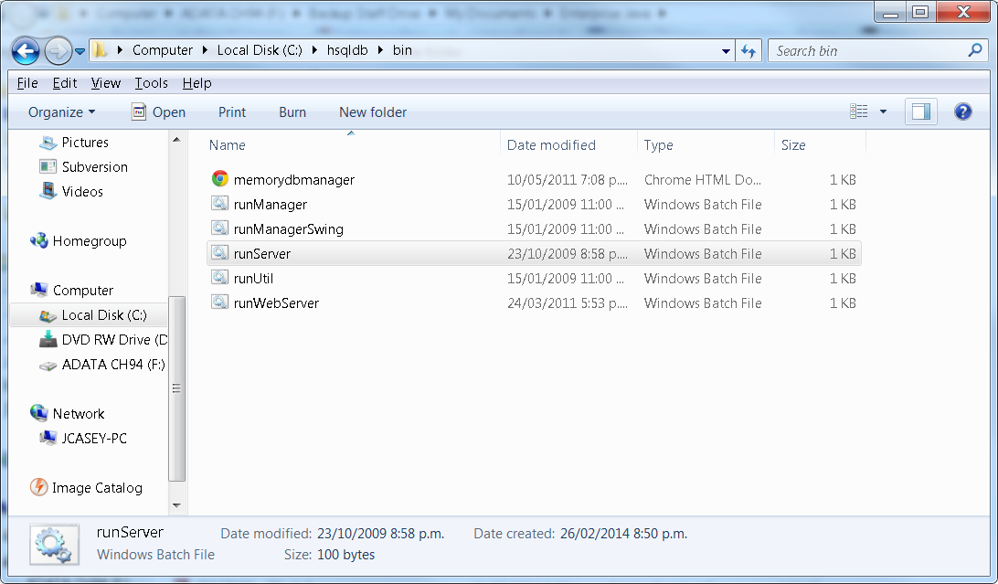

1. Once the database server has started you will see a console window with the following text.

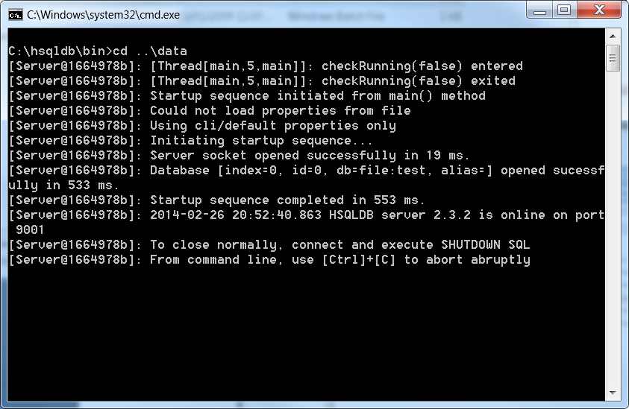

1. Open the HSQLDB Client Interface by running the batch file: *runManagerSwing* this will open the following window

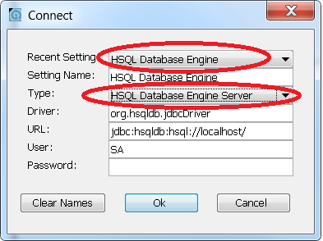

Please set the connection settings according to this diagram.

1. Finally, using the HSQLDB user interface create the BOOK table using the following SQL script.

|  |
| --- |
| CREATE TABLE BOOK  (  BOOK_ID INT NOT NULL,  TITLE varchar(50),  AUTHOR varchar(50),  GENRE varchar(50),  ISBN varchar(50),  BLURB varchar(250)  ); |

1. Once the BOOK table has been created insert the following records into your database and check that you can send SQL commands (queries etc) to your database table.

|  |
| --- |
| insert into Book (BOOK_ID,TITLE, AUTHOR, GENRE, ISBN, BLURB)  values (1,'Gone with the wind','Margaret Mitchell',  'Classic','1451635621','blah blah blah');  insert into Book (BOOK_ID,TITLE, AUTHOR, GENRE, ISBN, BLURB)  values (2,'A Clock Work Orange','Anthony Burgess','Dystopian Novella','0393312836','blah blah blah');  insert into Book (BOOK_ID,TITLE, AUTHOR, GENRE, ISBN, BLURB)  values (3,'2001: A Space Odyssey','Arthur C Clarke','Science Fiction','0451457994','blah blah blah');  insert into Book (BOOK_ID,TITLE, AUTHOR, GENRE, ISBN, BLURB)  values (4,'Make Room! Make Room!','Harry Harrison',  'Science Fiction','0765318857','blah blah blah');  insert into Book (BOOK_ID,TITLE, AUTHOR, GENRE, ISBN, BLURB)  values (5,'The Catcher in the Rye','JD Salinger',  'General','0316769177','blah blah blah'); |

1. Create a Java program to query the book table and display every record in the table
2. Create a variant of the Java program you created in step 5 to display all the Science Fiction books.
3. Create a JSP application to connect to the database and display all of the books in the database.
4. Alter the output so that entire table contents is output properly using HTML table tags – you will need to use both the ResultSet and the ResultSetMetaData objects.
5. Create a JSP application that is able to alter a user’s query based on input from a HTML form using a simple HTML text field and submit button.

